PROJECT MEMO
Predicting bottle quality from chemistry — four audiences
To: cellar lab, QC, winery GM, and the guest who asked “does the number mean anything?”
From: WineReg teaching pack · Short name: WineReg · Data: UCI red wine, n = 1,599

Why four versions
The attached audience notes split readers by data literacy, subject knowledge, and time span, and by role (expert / technician / executive / nonspecialist). One coefficient bar cannot serve all four. Below is the same C-grid and the same dropped density, rewritten.

1. Expert — oenologist / statistician
Binary cut at rating 5 is a convenience, not a sensory model. Features are standardized so w is log-odds per SD. Unpenalized MLE and L2 at C = 1 coincide on hold-out F1 = 0.727: the L2 ball still contains the MLE. A 5-fold F1 search on C ∈ [10⁻⁴, 10⁻²] returns C ≈ 0.002 (CV 0.773). Frozen-fold F1 = 0.735, AUC ≈ 0.81. L1-CV at C ≈ 0.26 sets density to 0, which matches the known linear dependence of density on alcohol and dissolved extract. Residual sugar and pH stay small. Do not interpret signs as causal “add sulphates, raise the score.” Events-per-variable is comfortable (~145). The 5-cut discards ordinal information; an ordinal or two-cut model is the next paper, not this one.

2. Technician — lab / QC
Scale the eleven tests before fitting. Leave-C-at-default is not a regularized method on this card — F1 does not move. Put C near 0.002 for ridge, or run the L1 path and drop density from the daily sheet. The tests that keep a large weight are alcohol, volatile acidity, total sulfur dioxide, and sulphates. Chlorides and free SO₂ are secondary. On 320 unseen bottles F1 is about 0.73. Use the predicted probability as a screen: send low-p lots to tasting, do not stamp “reserve” from the model alone. Recalibrate if the panel changes units or the vintage mix shifts.

3. Executive — winery GM / brand
A chemistry-only flag matches the historical good/not-good cut about as well as a mid-0.70s F1. That is good enough to pre-sort tanks, not good enough to replace a tasting panel. Tightening the software’s default penalty (smaller C) is free accuracy; dropping density is a cheaper panel. Treat the decision threshold as policy: a low bar catches more good lots and lets more poor lots through; a high bar protects a reserve label and misses some good juice. This is not a pricing tool and not a claim about marketing scores.

4. Nonspecialist — curious drinker
We asked eleven lab measurements to guess whether a red wine would have been scored above 5. Higher alcohol and a profile that is not sharp with vinegar (volatile acidity) help the guess. Regularization is the habit of not letting any one measurement shout. That habit quietly retired density — a number that mostly restates alcohol and sugar — and made the guess a little sturdier on bottles the model had not seen. Think of it as a sorting hat for the cellar, not a sommelier.

What the pictures are for
The unregularized bar is for the expert and the technician. The C-curve is for the technician and the GM (“the default setting was too soft”). The L1 bar with a flat density bar is for everyone: one test left the room. The ROC (AUC 0.81) is for the expert; do not lead a guest meeting with FPR/TPR axes.
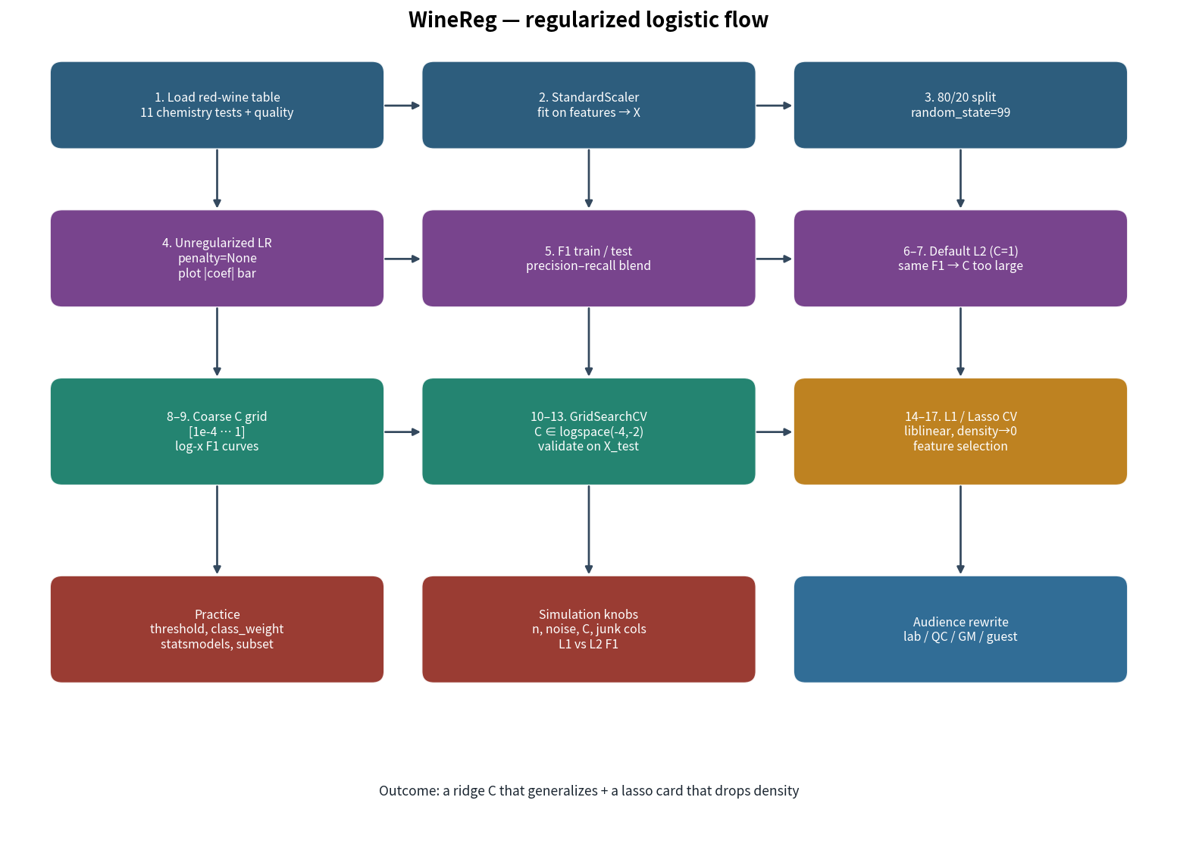

Limits to say out loud
- Red wine only. White wine chemistry is a different table.
- The 5-cut is not Parker points and not a shelf price.
- Hold-out n = 320. Do not quote three-decimal F1 as a brand KPI.
- random_state=99 moved the test prior to 48% good — mention the mix when you quote accuracy.

